**NRF24l01 FIRST TEST: YD_nRF24L01_Receive_JoyStick and YD_nRF24L01_Transmit_JoyStick**

**Procedure:**

1. Connect the transmitter side NRF first.

2. Upload the YD_nRF24L01_Transmitter_JoyStick code.

3. The output will be as shown below

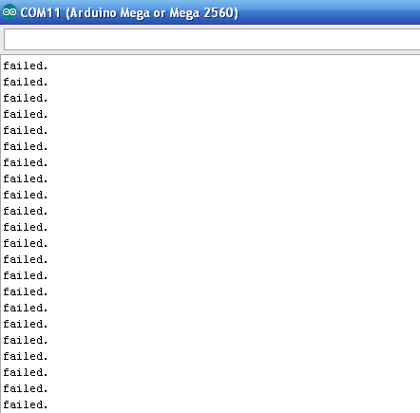

4. Now once you get the shown output connect the receiver side NRF.

5. Upload the YD_nRF24L01_Receive_JoyStick code to it.

6. The output will be as shown below

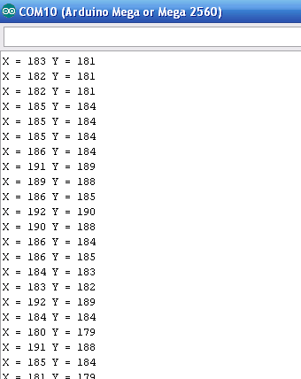

7. Now the transmitter side output will be

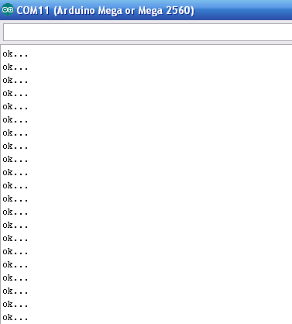

**References:**

You can find the code here <https://arduino-info.wikispaces.com/Nrf24L01-2.4GHz-HowTo> at the end of the page.

**Note:**

1. If you don’t get the output as same as above check the PIN connections in both arduino and CODE.
2. The PIN connections used in the link provided above are for arduino UNO board.
3. If you use another recheck the pin connections for your board here <https://arduino-info.wikispaces.com/Nrf24L01-2.4GHz-HowTo>